LEGAL DOCUMENT ANALYTICS
AND PATTERN SEARCH
A Data Structures and Algorithms - 3 Project Report
Project Report submitted for partial fulfilment of the requirements of
Data Structures and Algorithms - 3 (25CS2103E)
Department of Computer Science and Engineering
Academic Year 2026-27
SUBMITTED BY
Team Member | University Roll Number
B. L. Praveen | 2520030406
Dharani Dhar. T | 2520030163
Nishanth.T | 2520030313

Team Number: 12 | Section: 9
UNDER THE GUIDANCE OF
Dr. S. Vinay Kumar
Associate Professor
Department of Computer Science and Engineering

DEPARTMENT OF COMPUTER SCIENCE AND ENGINEERING
DECLARATION
We hereby declare that the project report entitled “Legal Document Analytics and Pattern Search” is a record of work carried out by our team in partial fulfilment of the requirements for the course Data Structures and Algorithms - 3 (25CS2103E) during the academic year 2026-27. The report describes the design, implementation, and testing of a Java-based academic application that applies string matching, dynamic programming, and network-flow techniques to a collection of legal-style text documents.
The supplied corpus contains synthetic test documents created for academic software testing. It is not a collection of authentic court records, and the application is not intended to provide legal advice. Any external algorithms or references used to prepare the report are acknowledged in the References section.

Student Name | Signature
B. L. Praveen | ________________________
Dharani Dhar. T | ________________________
Nishanth. T | ________________________

DEPARTMENT OF COMPUTER SCIENCE AND ENGINEERING
CERTIFICATE
This is to certify that the project report entitled “Legal Document Analytics and Pattern Search” is a record of the project work submitted by Praveen, Dharani, and Nishanth in partial fulfilment of the requirements for the course Data Structures and Algorithms - 3 (25CS2103E), Department of Computer Science and Engineering, during the academic year 2026-27.
The project applies algorithmic techniques to a text corpus and documents the implementation, results, and limitations of the work. The final acceptance of the report is subject to review and approval by the guide and the department.

Signature of the Guide | Signature of the HOD
________________________  Dr. S. Vinay Kumar  Associate Professor | ________________________  Dr. P. Venkateshwara Rao  Head of the Department

Signature of the External Examiner
____________________________

ACKNOWLEDGEMENT
We express our sincere gratitude to our project guide, Dr. S. Vinay Kumar, Associate Professor, Department of Computer Science and Engineering, for his guidance, feedback, and encouragement throughout the development of this Data Structures and Algorithms - 3 project. His emphasis on implementing algorithms meaningfully, integrating them into a common application, and presenting verifiable output helped shape the project into a coherent software system.
We also thank Dr. P. Venkateshwara Rao, Associate Professor and Head of the Department of Computer Science and Engineering, for providing the academic environment and direction required to complete the project. We acknowledge the course faculty for their observations on algorithm implementation, result comparison, code organization, and project integration.
Finally, we thank our teammates for their collaboration in studying, implementing, testing, and documenting the string-matching, dynamic-programming, and network-flow components. This project has helped us connect theoretical algorithm concepts with a working Java application and has reinforced the importance of testing, clear reporting, and honest discussion of software limitations.

B.L.Praveen | 2520030406
Dharani Dhar.T | 2520030163
Nishanth.T | 2520030313

ABSTRACT
Legal documents often contain repeated terms, related issues, and passages whose similarities can be useful to identify during document review. Manually scanning a large collection is time-consuming and inconsistent. This project, Legal Document Analytics and Pattern Search, develops a Java console application that uses Data Structures and Algorithms - 3 techniques on a shared corpus of legal-style text documents. The goal is educational: to demonstrate how algorithms for string search, sequence comparison, and network flow can be integrated into one working program rather than executed as disconnected examples.
The CO2 module searches a user-specified pattern through every corpus document and compares nine string-matching implementations: Naive Search, Knuth-Morris-Pratt (KMP), Z-function, Rabin-Karp, Aho-Corasick, Suffix Array Search, LCP/Kasai, Suffix Automaton, and a suffix-tree preview. It reports the number of documents containing the pattern, total occurrences, matching file names, execution times, and a consistency status. The CO3 module compares two documents using Levenshtein edit distance, Longest Common Subsequence (LCS), Needleman-Wunsch global alignment, and Smith-Waterman local alignment. It also demonstrates interval DP, bitmask DP, tree DP, and SOS/subset DP. The CO4 module derives a category-to-issue capacity network from the corpus and computes maximum flow and minimum cut.
The included test corpus contains 72 synthetic text documents, grouped into four categories with 18 documents per category. In a demonstration search for “property”, all nine CO2 implementations reported 36 matching documents and 144 total occurrences. For the default comparison of case001.txt and case002.txt, the CO3 module reported edit distance 69, LCS length 250, Needleman-Wunsch score 393, and Smith-Waterman score 405. The CO4 module reported a maximum flow and minimum cut value of 72. These results verify the integrated program on the supplied synthetic dataset; they are not claims about real court records or legal outcomes. Performance measurements depend on the machine and the implementation details, and limitations are documented in the report.
Keywords: Legal text corpus, string matching, KMP, Rabin-Karp, dynamic programming, sequence alignment, maximum flow, Java.

TABLE OF CONTENTS
Acknowledgement | 4
Abstract | 5
List of Figures and Tables | 7
1. Introduction | 8
1.1 Overview | 8
1.2 Problem Statement | 8
1.3 Scope of the Project | 8
1.4 Objectives | 9
1.5 Motivation and Expected Outcome | 9
2. System Requirements | 10
2.1 Functional Requirements | 10
2.2 Non-Functional Requirements | 10
2.3 Software and Hardware Requirements | 10
2.4 Assumptions | 11
3. System Design | 12
3.1 High-Level Architecture | 12
3.2 Description of Each Layer | 12
3.3 Data and Control Flow | 13
3.4 Algorithm Mapping and Team Contribution | 13
3.5 Data Model and Capacity Network | 13
4. Implementation | 15
4.1 Project Structure and Entry Point | 15
4.2 Corpus Loading | 15
4.3 CO2: Pattern Search | 15
4.4 CO3: Dynamic Programming | 16
4.5 CO4: Network Flow | 17
4.6 Build and Execution | 17
5. Results | 18
5.1 Test Setup | 18
5.2 CO2 Results | 18
5.3 CO3 Results | 19
5.4 CO4 Results | 20
5.5 Interpretation and Verification | 20
5.6 Test Summary | 20
6. Challenges and Limitations | 21
6.1 Issues Encountered | 21
6.2 Solutions Applied | 21
6.3 Limitations | 21
7. Conclusion and Future Work | 22
7.1 Conclusion | 22
7.2 Future Work | 22
7.3 Skills Learned | 22
References | 23

LIST OF FIGURES AND TABLES
Figure | Title | Page
Figure 3.1 | High-level architecture of the Legal Document Analytics Engine | 12
Figure 3.2 | CO2 pattern-search workflow | 13
Figure 3.3 | Illustrative CO4 corpus-derived flow network | 14

Table | Title | Page
Table 2.1 | Functional requirements | 10
Table 2.2 | Software requirements | 11
Table 3.1 | Algorithm ownership and responsibilities | 13
Table 4.1 | CO2 algorithm summary | 16
Table 5.1 | CO2 demonstration results | 18
Table 5.2 | CO3 demonstration results | 19
Table 5.3 | CO4 result summary | 20

1. INTRODUCTION

1.1 Overview
The project treats a collection of text files as a document corpus and applies several algorithm families to that shared dataset. The application is implemented in Java and has a single entry point, Main.java. At startup, the corpus loader reads the .txt files from the corpus directory and creates a collection of CorpusDocument objects. The main menu then allows the user to select pattern search (CO2), dynamic-programming document analysis (CO3), network-flow analysis (CO4), or a combined demonstration.
The project is designed as a practical demonstration of algorithm integration. Each algorithm is implemented as a reusable method, and the application layer calls those methods with the same user query or input data. This enables an apples-to-apples comparison of pattern-match counts and lets the program verify important properties, such as agreement among string-matching algorithms and equality of maximum flow and minimum cut.
The corpus shipped with the project consists of 72 synthetic legal-style test documents. It covers property, contract, criminal, and family categories. The text is generated for software testing and should not be mistaken for authentic judgments, statutes, or legal advice. The architecture is intended to allow an approved plain-text corpus to replace the sample corpus without changing the core algorithms.

1.2 Problem Statement
Searching for an important word or phrase across many legal documents can require repeated manual reading. Separate programs for separate algorithms also make it difficult to compare their answers, measure their performance under the same conditions, and explain how they contribute to one application. In addition, comparing documents only through exact pattern search cannot describe broader sequence similarity, while corpus counts alone do not demonstrate graph optimisation algorithms.
The problem addressed by this project is to design and implement a single console application that loads a legal-style text corpus and integrates (i) multiple string-matching algorithms for corpus-wide pattern search, (ii) dynamic-programming techniques for comparing document sequences and demonstrating advanced DP patterns, and (iii) maximum-flow/minimum-cut techniques on a network derived from document categories and issues. The application should produce readable, checkable output and describe its limitations.

1.3 Scope of the Project
- Input scope: plain UTF-8 text files stored in a local corpus directory. The current loader does not parse PDF, Word, scanned, or password-protected legal documents.
- Search scope: one text pattern is entered in the menu, normalized to lowercase and trimmed, then searched in each document by nine implementations. The current corpus and algorithms are intended mainly for lowercase English words.
- Similarity scope: two corpus files are selected and their first 300 whitespace-normalized characters are compared with four sequence-DP measures.
- Network-flow scope: category and primary-issue markers are read from the corpus to form a small directed capacity network. Flow results are algorithm demonstrations, not recommendations about cases.
- Deployment scope: a Java command-line application intended for academic demonstration and local execution; it has no graphical interface, database, external API, authentication, or production legal-workflow integration.

1.4 Objectives
- Integrate all nine CO2 pattern-search implementations into one consistent application workflow.
- Count matching documents and pattern occurrences and display a consistency check alongside measured runtimes.
- Apply edit distance, LCS, global alignment, and local alignment to selected document text portions.
- Demonstrate interval DP, bitmask DP, tree DP, and SOS/subset DP as additional algorithmic paradigms.
- Build a corpus-derived capacity network and report maximum flow, minimum cut, and a verification status.
- Provide a single entry point, understandable console output, documented build steps, and explicit limitations.

1.5 Motivation and Expected Outcome
The motivation is to connect theoretical DSA-3 algorithms with observable application behaviour. The expected outcome is not an automated legal decision-maker. It is a small, inspectable program that shows how different algorithms solve related computational subproblems, where their outputs agree, and where practical implementation choices affect runtime. By reusing a shared corpus and printing computed values, the project also provides a base for future improvements in data ingestion, testing, indexing, and visualization.
2. SYSTEM REQUIREMENTS

2.1 Functional Requirements
ID | Requirement | Expected behaviour
FR-01 | Load corpus | Read all .txt files from the corpus folder and sort them by filename.
FR-02 | Interactive menu | Offer CO2, CO3, CO4, combined demonstration, and exit options.
FR-03 | Pattern search | Accept a non-empty query and run all nine search implementations on each document.
FR-04 | Report search results | Show document-hit count, occurrence count, elapsed time, consistency status, and matching filenames.
FR-05 | Compare documents | Accept two known filenames and compute edit distance, LCS, Needleman-Wunsch, and Smith-Waterman values.
FR-06 | Show DP paradigms | Print matrix-chain cost, issue-route cost, tree independent-set result, and subset-DP result.
FR-07 | Flow analysis | Build a network from category/issue markers and compute flow and cut values.
FR-08 | Verification | Report whether search counts agree and whether the flow/cut check passes.

Table 2.1. Functional requirements.

2.2 Non-Functional Requirements
- Correctness: each CO2 method should return the same document and occurrence counts for supported search patterns; discrepancies should be visible rather than hidden.
- Understandability: output headings identify CO2, CO3, and CO4 separately, and reported values have labels that distinguish counts, distances, scores, costs, and capacities.
- Maintainability: algorithm classes are separated from corpus handling and application coordination; only Main.java contains main().
- Portability: the application uses standard Java APIs and can be compiled and run from a terminal or the VS Code integrated terminal.
- Performance awareness: elapsed time is measured with System.nanoTime(), but values are treated as machine-dependent measurements rather than universal benchmarks.
- Data honesty: the supplied corpus is explicitly identified as synthetic test data; results are not interpreted as findings about real cases.

2.3 Software and Hardware Requirements
Category | Requirement
Programming language | Java
Recommended runtime | JDK 17 or later, as stated in the project README
Editor / IDE | Visual Studio Code or any Java-compatible editor
Build tools | JDK compiler (javac) and Java launcher (java); no external dependency manager is required
Operating system | Any operating system with a compatible JDK; commands in this report use a Unix-like shell
Input data | A local corpus/ folder containing readable .txt documents
Hardware | A modern personal computer; memory and execution time increase with corpus size and DP input length

Table 2.2. Software and hardware requirements.

2.4 Assumptions
- The application is launched from the project root so the relative path corpus resolves correctly.
- Each document is readable as text and contains the category and primary-issue markers used by CO4 if it is to be classified accurately.
- The built-in example corpus and the CO3 300-character limit are intended for demonstration scale, not for unbounded document lengths.
- Search inputs should be non-empty lowercase/English words for the most reliable comparison across all nine current implementations.
3. SYSTEM DESIGN

3.1 High-Level Architecture
The architecture has four primary layers: console interaction, corpus loading and representation, algorithm/application engines, and result reporting. Main.java controls the menu and calls the relevant engine. CorpusLoader loads every text file in filename order. Each CorpusDocument holds a filename and lowercase document text. CO2SearchEngine, CO3Engine, and CO4Engine each use the same corpus representation while applying their own algorithm families.
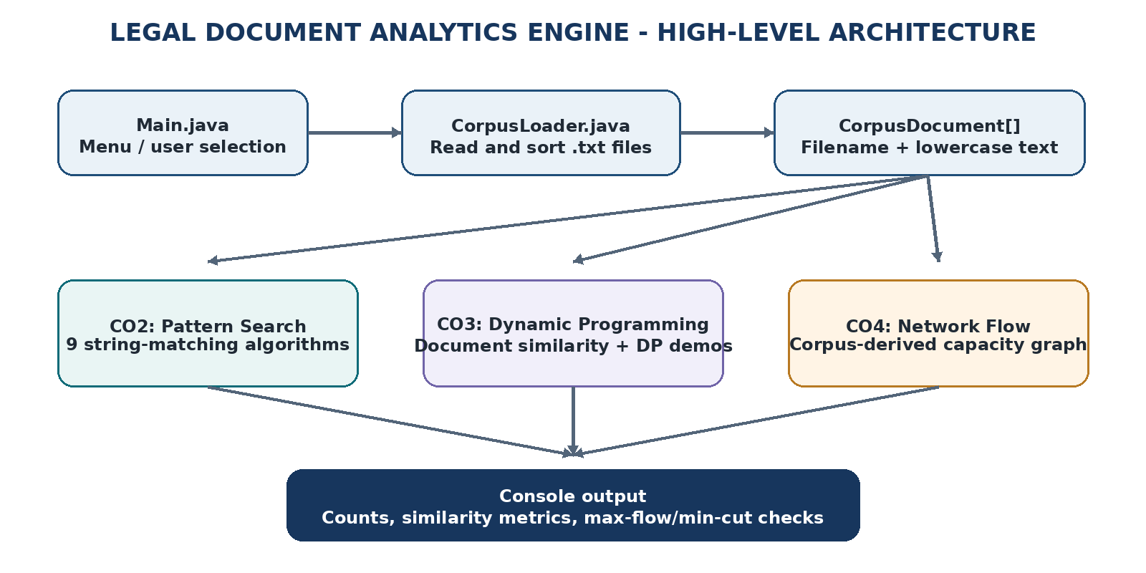
Figure 3.1. High-level architecture of the Legal Document Analytics Engine.
The design intentionally avoids separate executable entry points for individual algorithm files. The nine CO2 algorithms are reusable classes; DPAlgorithms contains the CO3 procedures; FlowAlgorithms contains reusable flow routines. The three engine classes provide project-specific orchestration and formatted output.

3.2 Description of Each Layer
Layer / class | Responsibility | Input and output
Main.java | Displays the main menu, reads selections, starts the requested module. | User choice and query/document names; console output.
CorpusLoader.java | Finds .txt files, orders them by name, reads their contents. | corpus/ directory; array of CorpusDocument objects.
CorpusDocument.java | Stores one file name and lowercase content. | Filename and file text.
CO2SearchEngine.java | Runs all nine search methods for each document and compares counts. | Pattern and corpus; per-algorithm counts, timings, status.
CO3Engine.java / DPAlgorithms.java | Selects two files, prepares text excerpts, computes sequence metrics and DP examples. | Two document names; distance, lengths, alignment scores and DP costs.
CO4Engine.java / FlowAlgorithms.java | Builds category-issue capacities and runs flow/cut calculations. | Corpus markers; capacities, max-flow values and min-cut check.

3.3 Data and Control Flow
At program start, Main invokes CorpusLoader.load("corpus"). The loader reads the files and returns the document array. The menu then routes control to the chosen engine. CO2 accepts a pattern and passes it through all implementations; CO3 resolves both filenames and compares limited text excerpts; CO4 counts categories and issues before building a small flow network. Each module prints its results directly to the terminal and returns to the main menu.
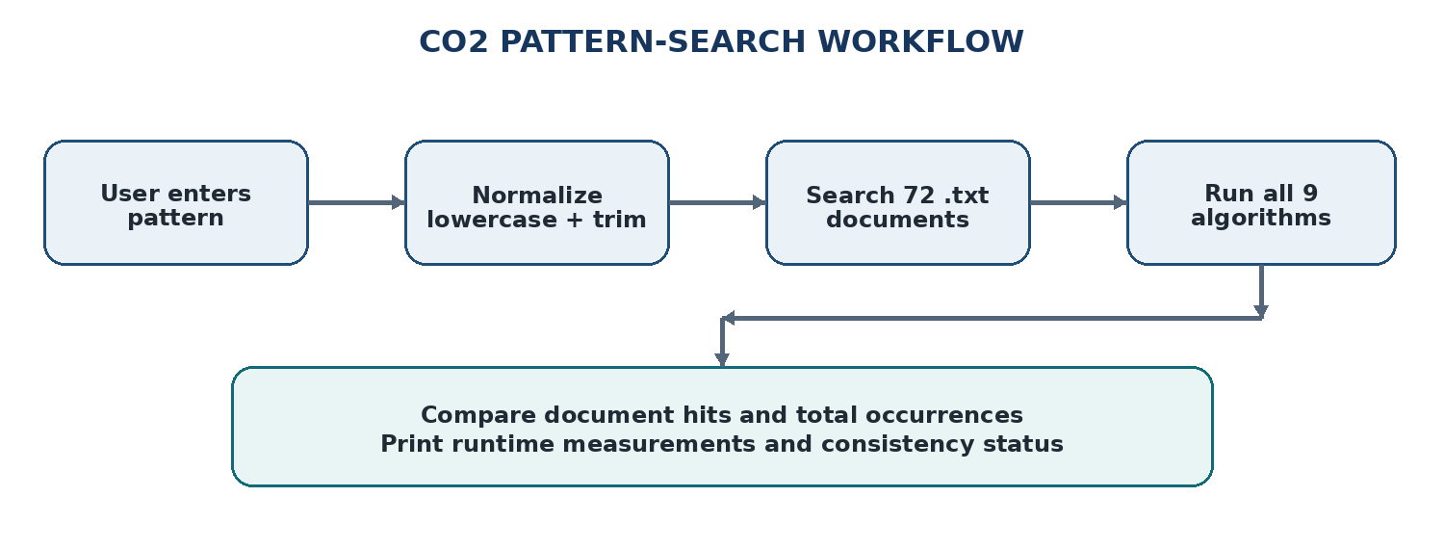
Figure 3.2. CO2 pattern-search workflow.

3.4 Algorithm Mapping and Team Contribution
The algorithm assignment is organized by team member in separate folders, while the application engines live at the project root. All algorithm classes are called from the integrated engines rather than requiring independent main methods.
Team member / folder | Algorithms assigned | Role in integrated application
Praveen  Praveen's_Algorithms/ | Naive Search; KMP; Z-function | First group of CO2 methods called by CO2SearchEngine.
Dharani  Dharani_Algorithms/ | Rabin-Karp; Aho-Corasick; Suffix Array Search | Second group of CO2 methods called by CO2SearchEngine.
Nishanth  Nishanth_Algorithms/ | LCP/Kasai; Suffix Automaton; Suffix Tree Preview | Third group of CO2 methods called by CO2SearchEngine.
Shared / root-level files | Corpus handling; CO2/CO3/CO4 engines; DP algorithms; flow algorithms; Main | Integration, corpus management, combined menu, result reporting.

Table 3.1. Algorithm ownership and responsibilities.
The names above use the first names supplied for this project. Full names and university roll numbers should be added to the cover, declaration, certificate, and acknowledgement before final submission.

3.5 Data Model and Capacity Network
CorpusDocument has two public final fields: name and text. The text is converted to lowercase by the constructor. The CO4 engine reads a CATEGORY marker and a PRIMARY ISSUE marker from each text. The directed network contains a source, four category nodes, four issue nodes, and a sink. The source-to-category capacity is the number of documents in that category; category-to-issue capacities are corpus-derived counts; issue-to-sink capacities are issue counts.
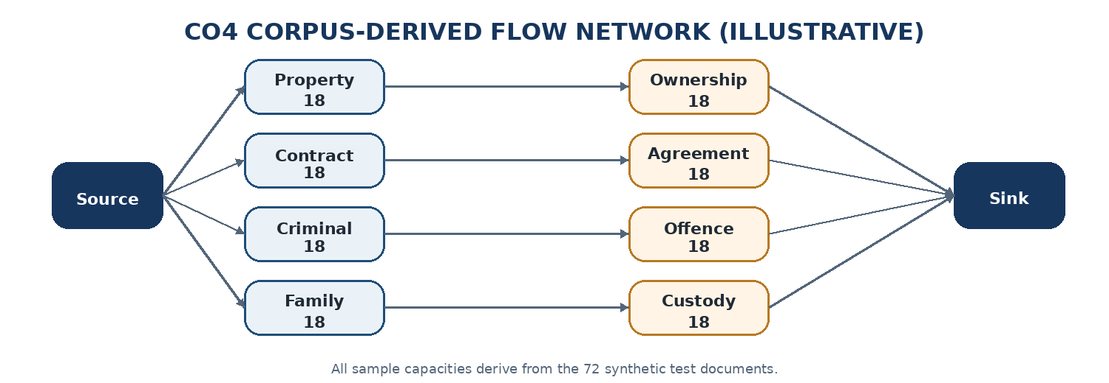
Figure 3.3. Illustrative category-to-issue capacity network. The sample corpus has 18 documents per category and issue.
Each document contributes to a category count and a primary-issue count. In the supplied sample, every category maps predominantly to one issue, so the four category-to-issue edges each carry capacity 18. The source capacities sum to 72, as do the issue-to-sink capacities. The max-flow/min-cut equality checks the aggregate network calculation; it does not establish a legal relationship or the evidential strength of any real case.
4. IMPLEMENTATION

4.1 Project Structure and Entry Point
The project is organized so that the integration layer can be distinguished from the algorithm implementations. The folder names identify the three member contribution groups. The remaining source files implement the corpus model, the application modules, shared DP routines, and network-flow procedures.
Path / file | Purpose
Main.java | Single program entry point and menu.
CorpusLoader.java; CorpusDocument.java | Read plain-text files and represent the corpus.
CO2SearchEngine.java | Dispatch the same pattern to nine algorithms; total and compare counts.
CO3Engine.java; DPAlgorithms.java | Document metrics and advanced DP demonstrations.
CO4Engine.java; FlowAlgorithms.java | Corpus-derived graph, maximum-flow and minimum-cut checks.
Praveen's_Algorithms/ | NaiveSearch.java, KMPSearch.java, ZSearch.java.
Dharani_Algorithms/ | RabinKarpSearch.java, AhoCorasickSearch.java, SuffixArraySearch.java.
Nishanth_Algorithms/ | LCPKasaiSearch.java, SuffixAutomatonSearch.java, SuffixTreeSearch.java.
corpus/ | 72 synthetic academic legal-style .txt files.
README.md; run.txt; .gitignore | Setup instructions, run commands, and ignored build artifacts.

4.2 Corpus Loading
CorpusLoader.load("corpus") lists the files in the provided folder, counts the files whose names end in .txt, sorts the file array alphabetically without case sensitivity, and reads each matching file with Files.readString. The resulting CorpusDocument objects are placed into an array. CorpusDocument converts each text to lowercase so the keyword search is case-insensitive for the supported character range. Whitespace collapsing is additionally used by CO3 before the 300-character excerpt is selected.
The generated corpus contains case001.txt through case072.txt. It is balanced across four categories: property, contract, criminal, and family, with 18 documents in each category. It is synthetic test data, not a real legal archive. Replacing the corpus with approved, anonymized text is possible provided the files remain plain-text and preserve the markers used by CO4.

4.3 CO2: Pattern Search
The user enters a non-empty pattern. CO2SearchEngine lowercases and trims the pattern, runs each algorithm against each document, stores the returned occurrence count, and measures elapsed nanoseconds for each algorithm. It then calculates the number of documents with at least one hit, adds occurrence counts over the corpus, compares each result with the Naive baseline, prints a consistency status, and lists matching documents using the KMP result array.
Algorithm | Core technique | Typical theoretical bound* | Implementation note
Naive | Try the pattern at every text position. | O(nm) | Baseline implementation.
KMP | Uses LPS/failure links to avoid rechecking matched prefix characters. | O(n + m) | Counts overlapping occurrences.
Z-function | Builds pattern + separator + text and uses Z-values. | O(n + m) | Separator is a non-printing character.
Rabin-Karp | Rolling polynomial hash followed by direct text verification. | Expected O(n + m); worst O(nm) | Uses one modulus/hash and verifies matches; no double-hash variant in this build.
Aho-Corasick | Trie with failure links for multi-pattern scanning. | O(n + total pattern length + matches) | Current menu wrapper passes one pattern at a time.
Suffix Array Search | Orders suffix starts and binary-searches the pattern range. | Optimized construction often O(n log n) | Current suffix order uses insertion-sort-style rank ordering, so this implementation is slower than optimized versions.
LCP/Kasai | Suffix array plus longest-common-prefix array. | Kasai LCP phase O(n) | Suffix sorting in this build uses a simple insertion-sort method and is expensive on longer text.
Suffix Automaton | Builds a compact state machine for substrings and occurrence frequencies. | O(n) for standard alphabet/state operations | Current state transitions support lowercase a-z.
Suffix Tree Preview | Query-length suffix trie/tree-style educational preview. | Depends on represented suffix depth and text size | Not a full compressed suffix-tree implementation; labeled preview in output.

Table 4.1. CO2 algorithm summary and implementation notes.
*Theoretical bounds describe standard forms of the algorithms; actual runtime is affected by the specific implementation, alphabet, query, input sizes, and computer. The two suffix-array-related implementations use simple sorting code and should not be presented as optimized implementations of the textbook bounds.

4.4 CO3: Dynamic Programming
CO3 resolves two requested filenames, converts repeated whitespace to a single space, and selects the first 300 characters from each document (or the full text if it is shorter). The selected strings are compared with four sequence algorithms. The implementation uses a substitution score of +2 for a matching character and -1 for a mismatch, and a gap penalty of -2 for Needleman-Wunsch and Smith-Waterman.
Measure / DP pattern | What it measures | How to interpret the output
Levenshtein edit distance | Minimum insertions, deletions, and substitutions to transform one string into another. | Lower values usually indicate greater character-level similarity.
Longest Common Subsequence (LCS) | Length of the longest shared subsequence that preserves order but need not be contiguous. | Higher values indicate more shared ordered content; value is a length, not a percentage.
Needleman-Wunsch | Global sequence alignment score across both strings. | Score depends on match, mismatch, and gap settings; not a percentage.
Smith-Waterman | Best local alignment score between regions of the strings. | Higher scores suggest a stronger local match under the configured scoring.
Interval DP: matrix-chain | Minimum scalar multiplication cost for a small matrix sequence. | A standalone example of interval-optimization DP.
Bitmask DP: TSP | Minimum cost tour over a small issue-route graph. | A standalone example of DP over visited subsets.
Tree DP: independent set | Maximum number of non-adjacent selected nodes in a small tree. | Demonstrates parent-child state decisions.
SOS/subset DP | Counts corpus issue masks containing each subset mask. | Demonstrates subset aggregation over bitmasks.

The additional four DP demonstrations are intentionally labeled separately from document similarity. Their numeric outputs are costs or state results for small built-in examples, not similarity scores for the chosen documents.

4.5 CO4: Network Flow
CO4 classifies each document using the category marker and primary-issue marker, aggregates the counts, and constructs a directed capacity matrix. A source connects to the four category nodes. Category nodes connect to issue nodes when the corpus contains documents for that category-issue combination. Issue nodes connect to a sink using issue counts. The application prints the category counts, issue capacities, category-to-issue capacities, maximum-flow values, and the capacity of a minimum cut computed from the residual network.
FlowAlgorithms includes a BFS-based augmenting-path routine, a Dinic implementation using level graphs and DFS, and a source-side residual reachability routine for the cut calculation. In the current source, the method named edmondsKarp delegates to the same Ford-Fulkerson method rather than providing a separate code path. This implementation detail is listed as a limitation because the reported agreement between those two labels is not an independent cross-implementation test.

4.6 Build and Execution
From the root directory of the project, with JDK 17 or later installed, compile the Java sources and place compiled classes in the output folder:
javac -d out "Praveen's_Algorithms"/*.java Dharani_Algorithms/*.java Nishanth_Algorithms/*.java *.java
java -cp out Main
Menu options are: 1 for CO2 search, 2 for CO3 document comparison, 3 for CO4 flow analysis, 4 for the combined demonstration, and 0 to exit. Run from the project root so the relative corpus path resolves correctly.
5. RESULTS

5.1 Test Setup
The build was compiled and executed with the provided Java source files and synthetic corpus. The corpus contains 72 text files: 18 property documents, 18 contract documents, 18 criminal documents, and 18 family documents. The combined demonstration uses the query “property”, compares case001.txt and case002.txt in CO3, and derives the CO4 network from all 72 documents. Timing values are intentionally not recorded as fixed performance claims because they depend heavily on the computer and on the simple suffix-ordering routines used here.

5.2 CO2 Results
For the pattern “property”, every algorithm reported the same number of matching documents and total occurrences. This is a useful consistency test because each algorithm uses a different search strategy while receiving the same corpus and normalized query.
Algorithm | Documents with a match | Total occurrences | Consistency
Naive | 36 | 144 | Baseline
KMP | 36 | 144 | Agree
Z-function | 36 | 144 | Agree
Rabin-Karp | 36 | 144 | Agree
Aho-Corasick | 36 | 144 | Agree
Suffix Array Search | 36 | 144 | Agree
LCP/Kasai | 36 | 144 | Agree
Suffix Automaton | 36 | 144 | Agree
Suffix Tree Preview | 36 | 144 | Agree

Table 5.1. CO2 corpus-search results for the test query “property”.
The output shows “Result consistency: PASS - all algorithms agree”. The matching-document list is printed using KMP counts. The measured time for each algorithm is displayed during program execution and varies by machine. In the tested simple implementation, suffix-array construction and LCP/Kasai were notably slower than linear-time pattern scanners; their purpose here is to demonstrate the data structures and method rather than claim an optimized benchmark.

5.3 CO3 Results
The combined demonstration compares case001.txt and case002.txt, which are both part of the synthetic corpus. The engine compares the first 300 whitespace-normalized characters from each document.
Metric | Observed result | Meaning
Levenshtein edit distance | 69 | Minimum character edits under insert/delete/replace operations.
LCS length | 250 | Length of the longest shared ordered subsequence.
Needleman-Wunsch global score | 393 | Global alignment score using match +2, mismatch -1, gap -2.
Smith-Waterman local score | 405 | Best local alignment score with the same scoring parameters.
Matrix-chain interval DP cost | 10500 | Cost of the built-in matrix-chain example; not document similarity.
Bitmask DP issue-route cost | 16 | Tour cost in the small built-in route matrix.
Tree DP maximum independent set | 2 | Maximum selected nodes in the built-in tree example.
SOS/subset DP all-issue subset count | 1 | Count for the full subset in the built-in mask example.

Table 5.2. CO3 outputs for the default document pair and supplementary DP examples.
Edit distance and LCS express different aspects of similarity. Edit distance is a cost to transform one sequence into another, so smaller values are generally better. LCS is a shared-length value, so larger values indicate more ordered content in common. Needleman-Wunsch and Smith-Waterman return scores controlled by their scoring scheme; neither score should be reported as a percentage. The last four values are separate educational examples and must not be mixed with the document-comparison metrics.

5.4 CO4 Results
Network item | Observed count / capacity
Property category | 18 documents
Contract category | 18 documents
Criminal category | 18 documents
Family category | 18 documents
Ownership issue | 18 documents
Agreement issue | 18 documents
Offence issue | 18 documents
Custody issue | 18 documents
Ford-Fulkerson result | 72
Edmonds-Karp-labelled result | 72
Dinic result | 72
Minimum cut capacity | 72

Table 5.3. CO4 network and flow results for the 72-document synthetic corpus.
The CO4 consistency message reports PASS because the three reported flow values are equal and the calculated minimum cut is also 72. This is expected for the current balanced sample graph. It verifies the flow/cut relationship for the generated network, although the current Edmonds-Karp method shares implementation with the Ford-Fulkerson method as described in Section 4.5.

5.5 Interpretation and Verification
- The CO2 output provides a meaningful count comparison across nine algorithms instead of printing only the algorithm names.
- The CO3 output distinguishes sequence-similarity values from auxiliary DP demonstration costs, preventing the values 10500, 16, 2, and 1 from being interpreted as similarity scores.
- The CO4 output exposes the category and issue capacities before showing flow results, making the network construction inspectable.
- The 72-document corpus is synthetic, and runtimes depend on the machine, Java version, corpus, query, and measurement procedure; results do not establish accuracy on real legal repositories.

5.6 Test Summary
Test | Expected check | Observed outcome
Compile all source files | Compilation completes without errors. | PASS
Load corpus | 72 .txt documents are loaded. | PASS
CO2 search: “property” | All nine algorithms return equal counts. | PASS: 36 documents, 144 occurrences each
CO3 default pair | Four similarity/alignment metrics and four DP demos are printed. | PASS
CO4 network | All reported flow values equal min-cut. | PASS: all are 72 for the sample corpus

6. CHALLENGES AND LIMITATIONS

6.1 Issues Encountered
- Disconnected code: separate main methods make individual algorithm demonstrations difficult to combine and compare in one application.
- Result trustworthiness: printing algorithm names without computed counts would not demonstrate that the algorithms actually searched the corpus.
- Output interpretation: edit distance, subsequence length, alignment scores, DP costs, flow values, and timings are different quantities and need separate labels.
- Performance differences: construction-heavy suffix methods are slower in this academic implementation than simple linear-time search methods.
- Input constraints: the suffix automaton and suffix-tree preview operate over lowercase alphabet transitions, and the included corpus contains mostly English text.
- Flow method duplication: the method labelled Edmonds-Karp currently reuses the Ford-Fulkerson BFS routine instead of independently implementing the named algorithm.

6.2 Solutions Applied
- Created one Main.java entry point and made algorithm classes reusable methods without their own main() methods.
- Connected the CO2, CO3, and CO4 engines to the same corpus representation and added a combined demonstration option.
- Recorded computed occurrence counts, document counts, execution times, and explicit consistency messages in CO2.
- Separated CO3 similarity outputs from the four auxiliary DP examples and added explanations of how to interpret each metric.
- Printed the CO4 category counts, issue capacities, category-to-issue edges, max-flow outputs, and minimum-cut value.
- Identified the synthetic nature of the corpus and documented current algorithm-level caveats instead of presenting the prototype as a production legal-search system.

6.3 Limitations
- The shipped corpus is synthetic, balanced, and small. Its behaviour may not represent real legal documents with varied lengths, formats, vocabulary, and noise.
- Input is limited to plain text. PDF extraction, OCR, stemming, lemmatization, stop-word handling, phrase query syntax, Unicode normalization, and metadata filtering are not implemented.
- CO3 compares only the first 300 normalized characters. Text after that excerpt does not affect the current similarity values.
- Alignment scores depend on fixed scoring constants and are raw scores rather than calibrated similarity percentages.
- Rabin-Karp uses one rolling hash with direct verification; a double-hash option is not implemented.
- The suffix-array and LCP/Kasai versions use simple insertion-sort-style suffix ordering, which is inefficient for larger documents; runtime measurements are also sensitive to the machine, JVM warm-up, corpus size, and query.
- The suffix-tree module is explicitly a preview based on a query-length suffix trie, not a full compressed suffix tree.
- The current Edmonds-Karp entry point delegates to the Ford-Fulkerson implementation. The flow algorithms should be refactored before claiming independent performance comparison between those methods.
- The CO4 network classifies documents from simple text markers; it does not reason about legal facts or establish relationships between real cases.
7. CONCLUSION AND FUTURE WORK

7.1 Conclusion
The project integrates three algorithm-oriented components into one Java console application over a common document corpus. CO2 runs nine string-search methods on the same query and reports matching document counts, total occurrences, runtimes, and result consistency. CO3 applies edit distance, LCS, global alignment, and local alignment to compare bounded portions of two selected documents, while also showing small examples of interval, bitmask, tree, and subset DP. CO4 constructs a category-to-issue capacity network from corpus markers and displays max-flow and min-cut values.
On the included 72-document synthetic corpus, the query “property” produced 36 matching documents and 144 occurrences for each CO2 algorithm. The default CO3 comparison of case001.txt and case002.txt produced an edit distance of 69, LCS length of 250, Needleman-Wunsch score of 393, and Smith-Waterman score of 405. The CO4 demonstration produced a flow value and minimum-cut capacity of 72. These outputs show that the integrated application executes and reports its intended calculations for the provided test data.
The project also demonstrates that a result should be interpreted in the context of its algorithm and implementation. Raw alignment scores are not percentages; auxiliary DP costs are not similarity scores; timing is machine-dependent; and the current implementation has specific limitations in suffix indexing, alphabet handling, and flow-method independence. Documenting these issues is part of evaluating the software accurately.

7.2 Future Work
- Replace the synthetic files with a permitted, anonymized legal-text corpus and define a repeatable evaluation set.
- Add PDF/DOCX extraction, Unicode normalization, metadata filters, and robust multiword-query support.
- Optimize suffix-array and LCP implementations, and implement a full compressed suffix tree instead of the current preview.
- Add Rabin-Karp double hashing and automated edge-case tests for overlapping matches, punctuation, empty patterns, and Unicode.
- Implement Edmonds-Karp independently and compare the flow algorithms on standard test networks.
- Improve full-document or chunk-based similarity, normalize metrics, and rank similar documents; add reproducible benchmarks and optional JSON/CSV output or a small GUI.

7.3 Skills Learned During Development
- Implementing string-matching algorithms and comparing their outputs on identical input data.
- Applying DP recurrences to sequence similarity, interval optimization, bitmask states, trees, and subsets.
- Modeling corpus-derived counts as a flow network and checking max-flow/min-cut consistency.
- Integrating a multi-file Java application, testing it, documenting results, and explaining implementation limitations clearly.

REFERENCES
[1] T. H. Cormen, C. E. Leiserson, R. L. Rivest, and C. Stein, Introduction to Algorithms, 4th ed. Cambridge, MA: MIT Press, 2022.
[2] D. Gusfield, Algorithms on Strings, Trees, and Sequences: Computer Science and Computational Biology. Cambridge: Cambridge University Press, 1997.
[3] D. E. Knuth, J. H. Morris, Jr., and V. R. Pratt, “Fast pattern matching in strings,” SIAM Journal on Computing, vol. 6, no. 2, pp. 323-350, 1977.
[4] A. V. Aho and M. J. Corasick, “Efficient string matching: An aid to bibliographic search,” Communications of the ACM, vol. 18, no. 6, pp. 333-340, 1975.
[5] S. B. Needleman and C. D. Wunsch, “A general method applicable to the search for similarities in the amino acid sequence of two proteins,” Journal of Molecular Biology, vol. 48, no. 3, pp. 443-453, 1970.
[6] T. F. Smith and M. S. Waterman, “Identification of common molecular subsequences,” Journal of Molecular Biology, vol. 147, no. 1, pp. 195-197, 1981.
[7] Oracle, “Java Platform, Standard Edition Documentation.” Available: https://docs.oracle.com/en/java/ (accessed October 2026).
[8] Team 12, “Legal Document Analytics and Pattern Search: DSA-3 project source code and synthetic test corpus,” project repository: https://github.com/lt-praveen/Team-12_DSA3-Project (accessed October 2026).
[9] Team 12, “Project Documentation format 2026-27,” department-provided report template, academic year 2026-27.

